UI Flowcharts

A UI flowchart used to describe the logical relationship between pages. It is a picture of the separate steps of a process in sequential order.

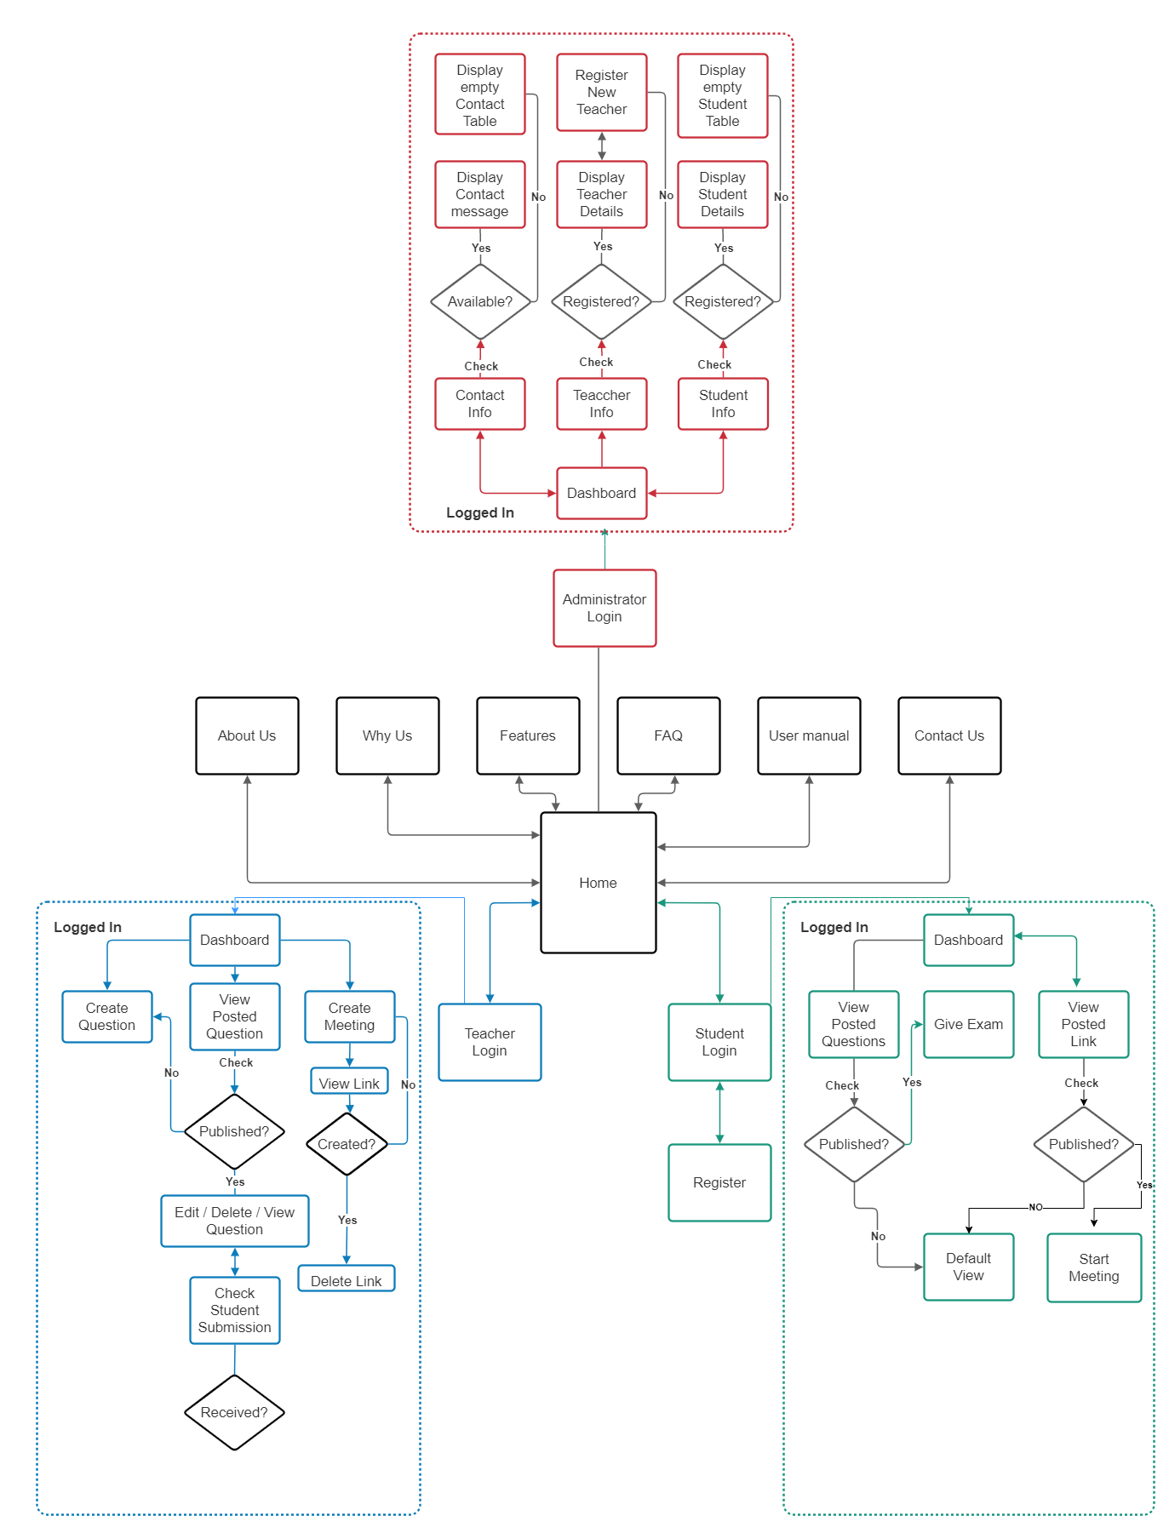

Figure 8: UI Flowcharts of Lu Exam Hive

UI Design

User interface (UI) design is the process designers use to build interfaces in software or computerized devices, focusing on looks or style. Designers aim to create interfaces which users find easy to use and pleasurable.

Graphical user interfaces (GUIs)—Users interact with visual representations on digital control panels. A computer’s desktop is a GUI.

Home View (Users)

Home View has links to most of the key pages of the website and also is the place where messages are conveyed to the users i.e. reasons to use the website, selecting their avatar, tips & life hacks for the students & to whom is this site made for.

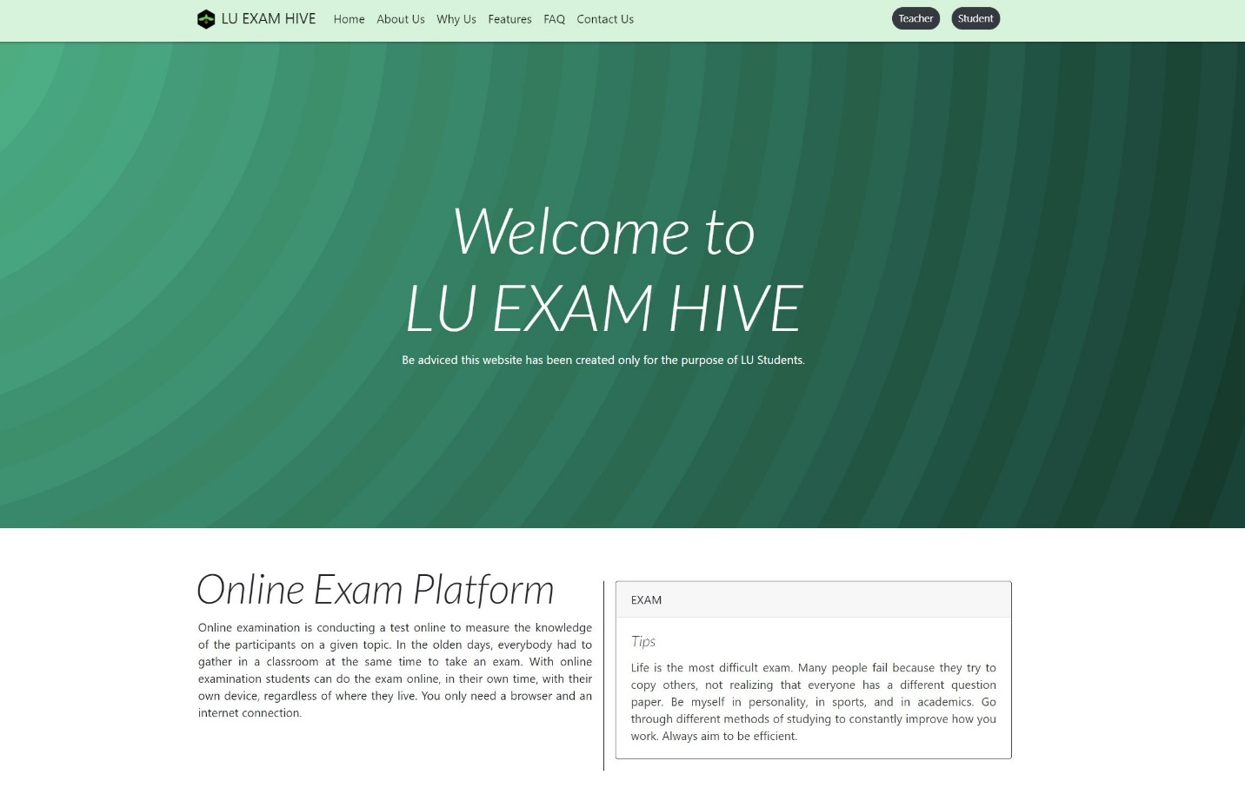

Figure 9: Home View of Lu Exam Hive

About Us (Users)

A short Video of the website mainly showing students how to use the platform.

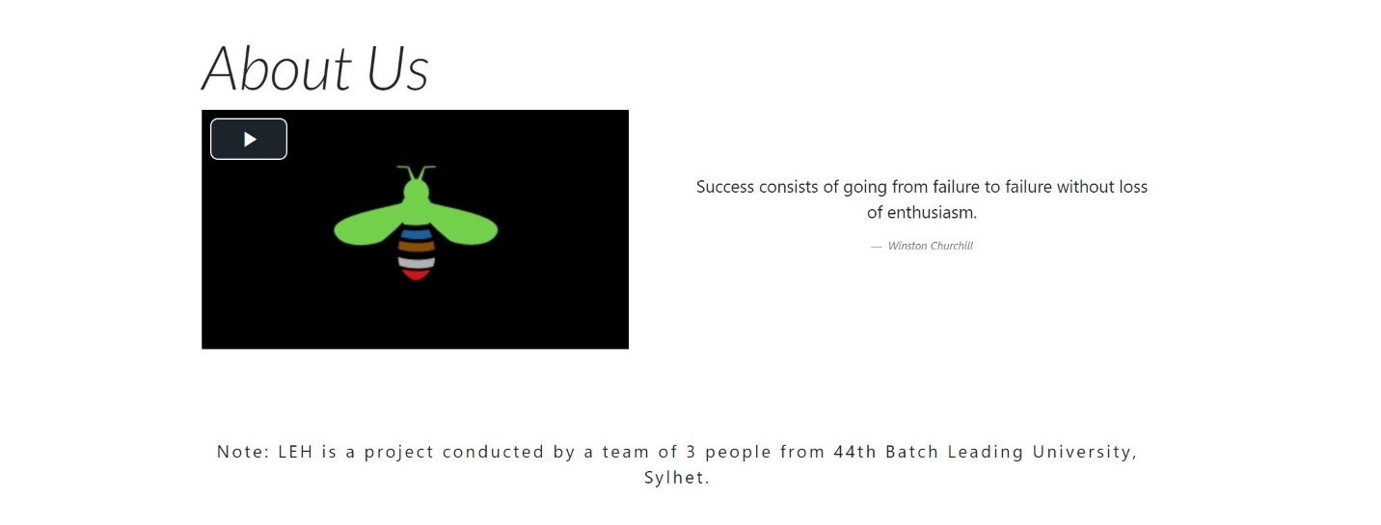

Figure 10: About Us of Lu Exam Hive

Why Exam Hive? (Users)

Key reasons are stated in this section for the users to get onto Lu Exam Hive.

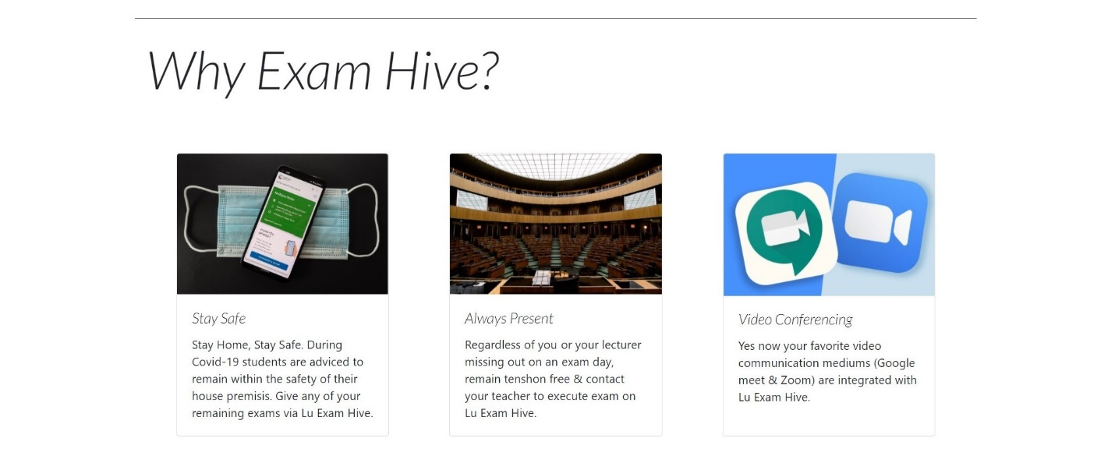

Figure 11: Why Exam Hive? of Lu Exam Hive

Features (Users)

Attractive features of the website are stated in this section to draw attention of the users.

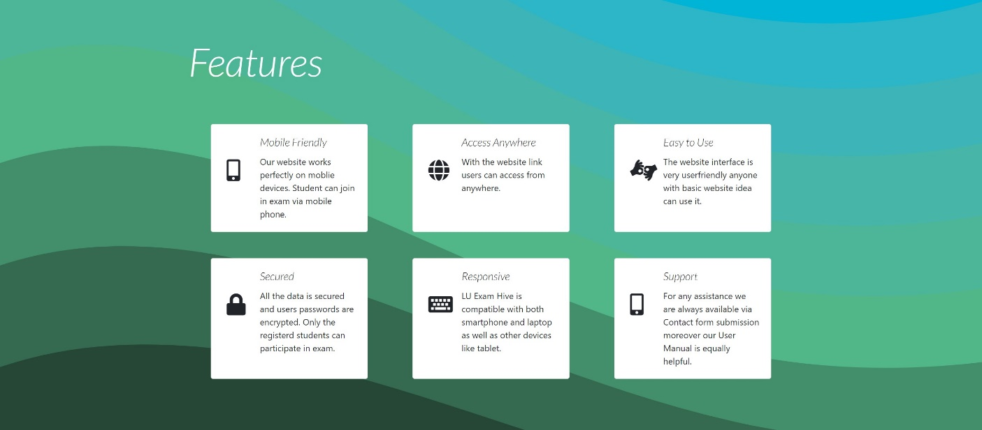

Figure 12: Features of Lu Exam Hive

FAQ (Users)

Quick response to curious & common questions of Users are placed in this section.

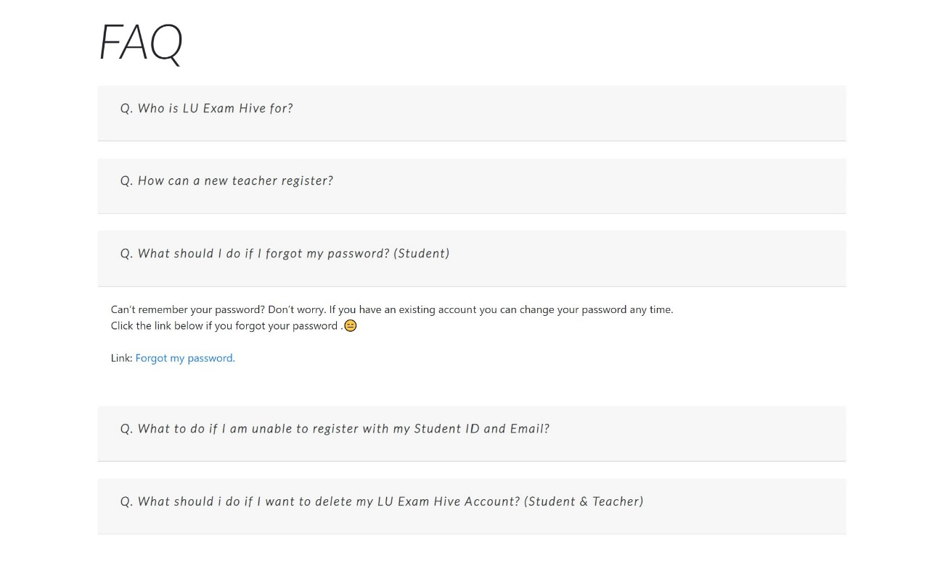

Figure 13: FAQ of Lu Exam Hive

Contact Us (Users)

Users can reach out to us with their query regarding any problem related to the website using Contact Us form which is present in almost every page via link.

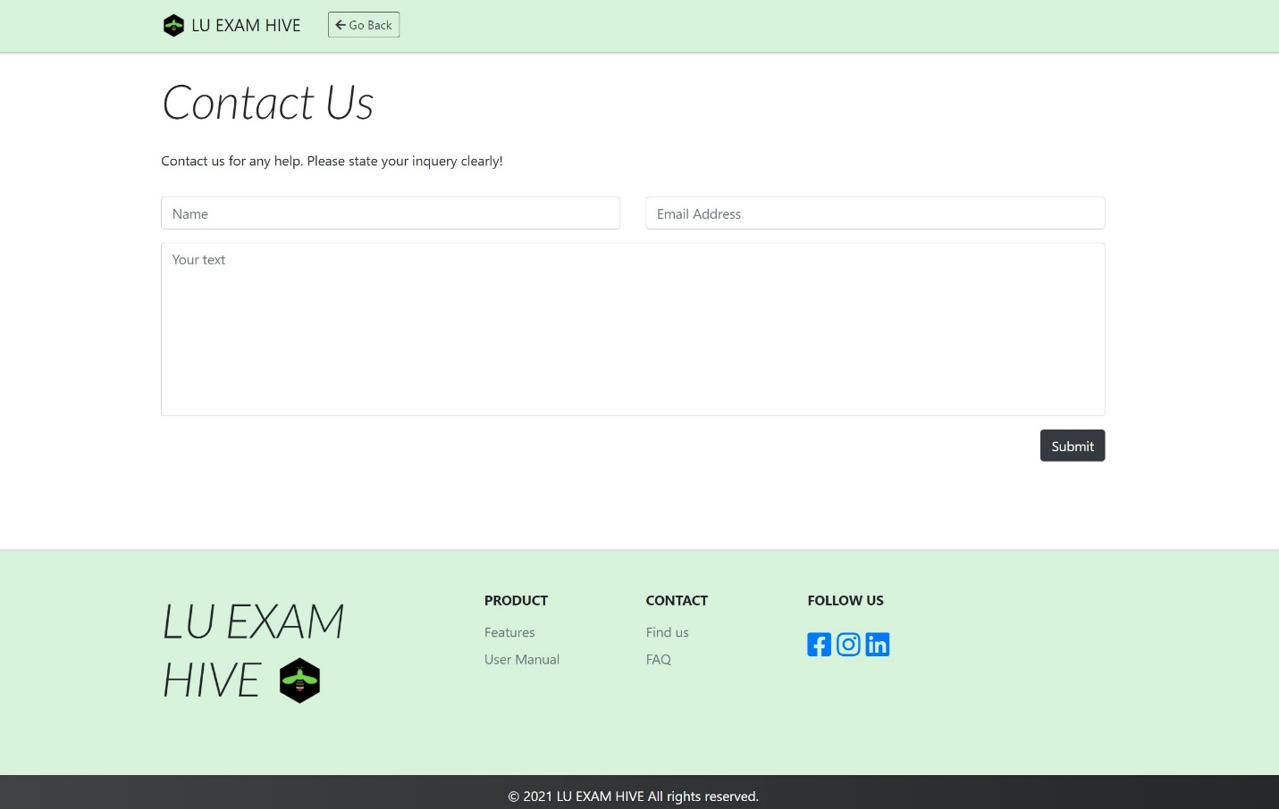

Figure 14: Contact Us of Lu Exam Hive

Login (Teacher)

Lu Exam Hive designs UI of Teachers login uniquely which is simple, easy to understand and smooth to use. New teacher will have to reach out to the administrator via contact us form following the procedure provided in the FAQ section to get registered to the site.

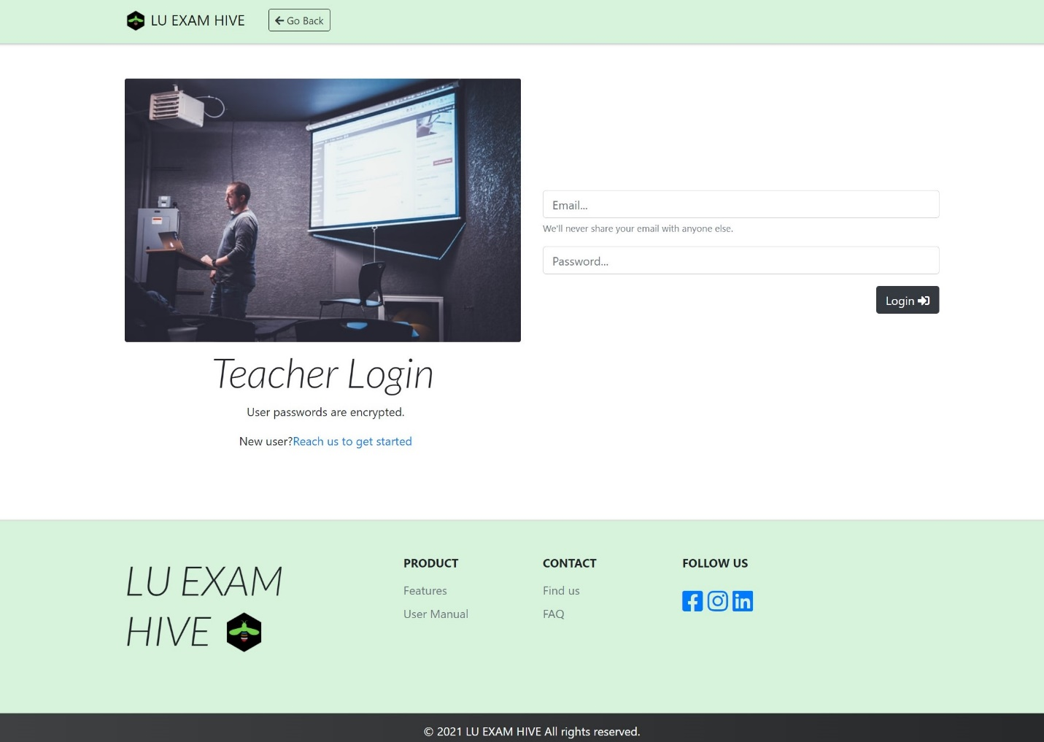

Figure 15: Teacher Login of Lu Exam Hive

Login (Student)

Lu Exam Hive understands that all students of a university are not familiar with complex UI thus keeping the accessibility aspect of every student in mind the login interface is designed to be simple, clear and easy to understand.

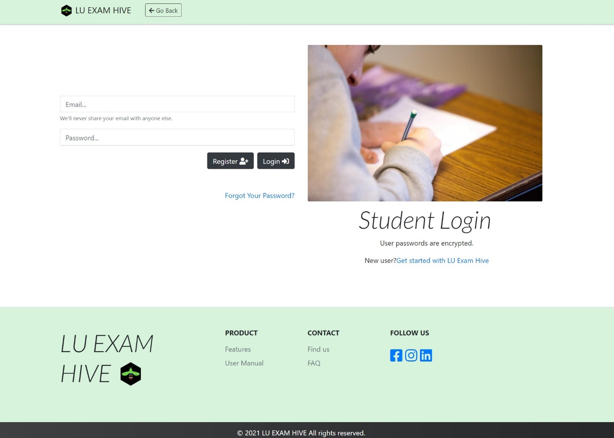

Figure 16: Student Login of Lu Exam Hive

Login (Admin)

Admin login has to be approached via URL using (/admin_login.php) after the site name.

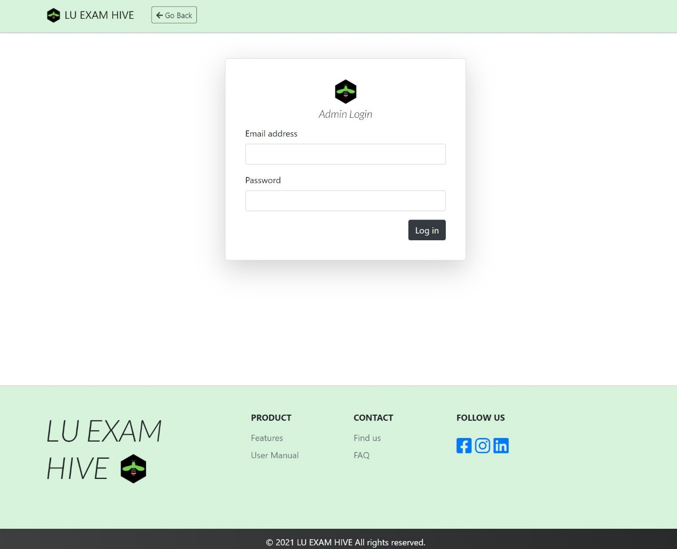

Figure 17: Admin Login of Lu Exam Hive

Registration (Student)

Students of the University will be requested to fill in this form in order to further navigate the pages of LU Exam Hive. After registration an OTP will be sent to user email address for verification.

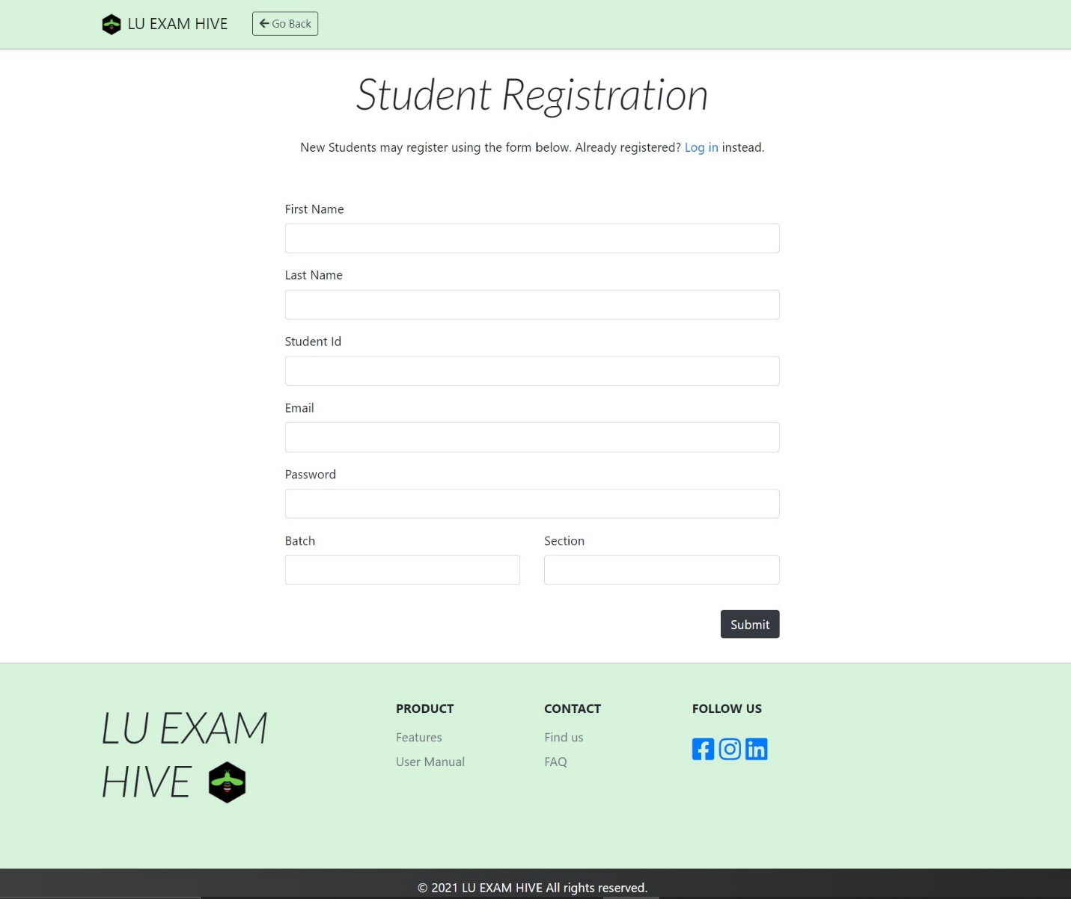

Figure 18: Student Registration Form of Lu Exam Hive

Forgot Password (Student)

We often do forget our passwords thus not to worry, Lu Exam Hive has u covered.

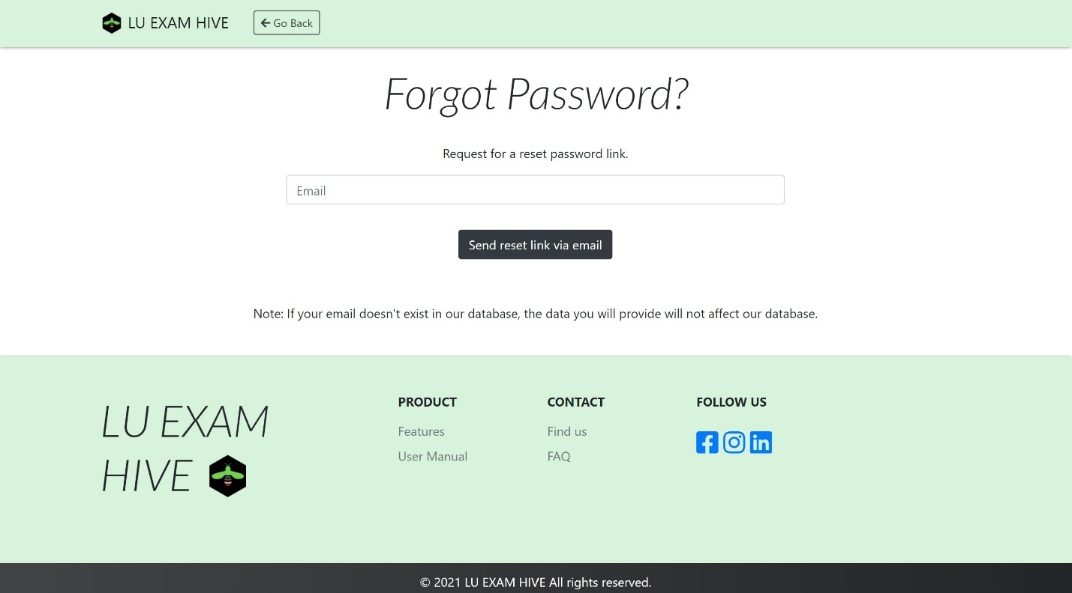

Figure 19: Forgot Password of Lu Exam Hive

Dashboard (Teacher)

Keeping in mind that not all teachers are familiar to complex UI of a dashboard of online exam platforms, thus we designed easy to understand dashboard for easy navigation. Creating Meeting Links, Questions, Edit questions, deleting them Posting or keeping a Draft of Question for later post, seeing self-posted questions, viewing own questions, checking submitted solutions from students, marking them and then generating a pdf of the result sheet. Yes we have it all under one platform.

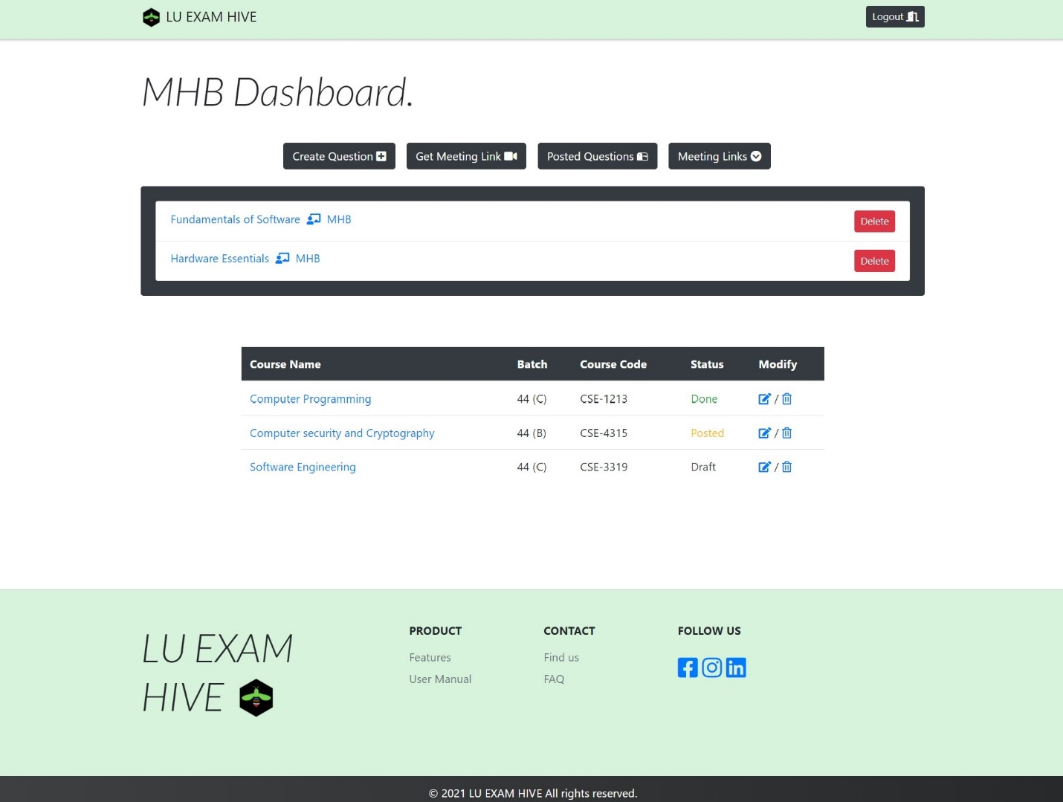

Figure 20: Teacher Dashboard of Lu Exam Hive

Create Question (Teacher)

In this area teachers will fill in the details of a section whose exam or assignment is to be conducted. It is to be kept in mind that Summernote is integrated to the Question making section of the website. (Summernote is a JavaScript library that helps you create WYSIWYG editors online. Summernote is built on jQuery.) Thus Teachers can attach any pictures easily to the questions and do much more.

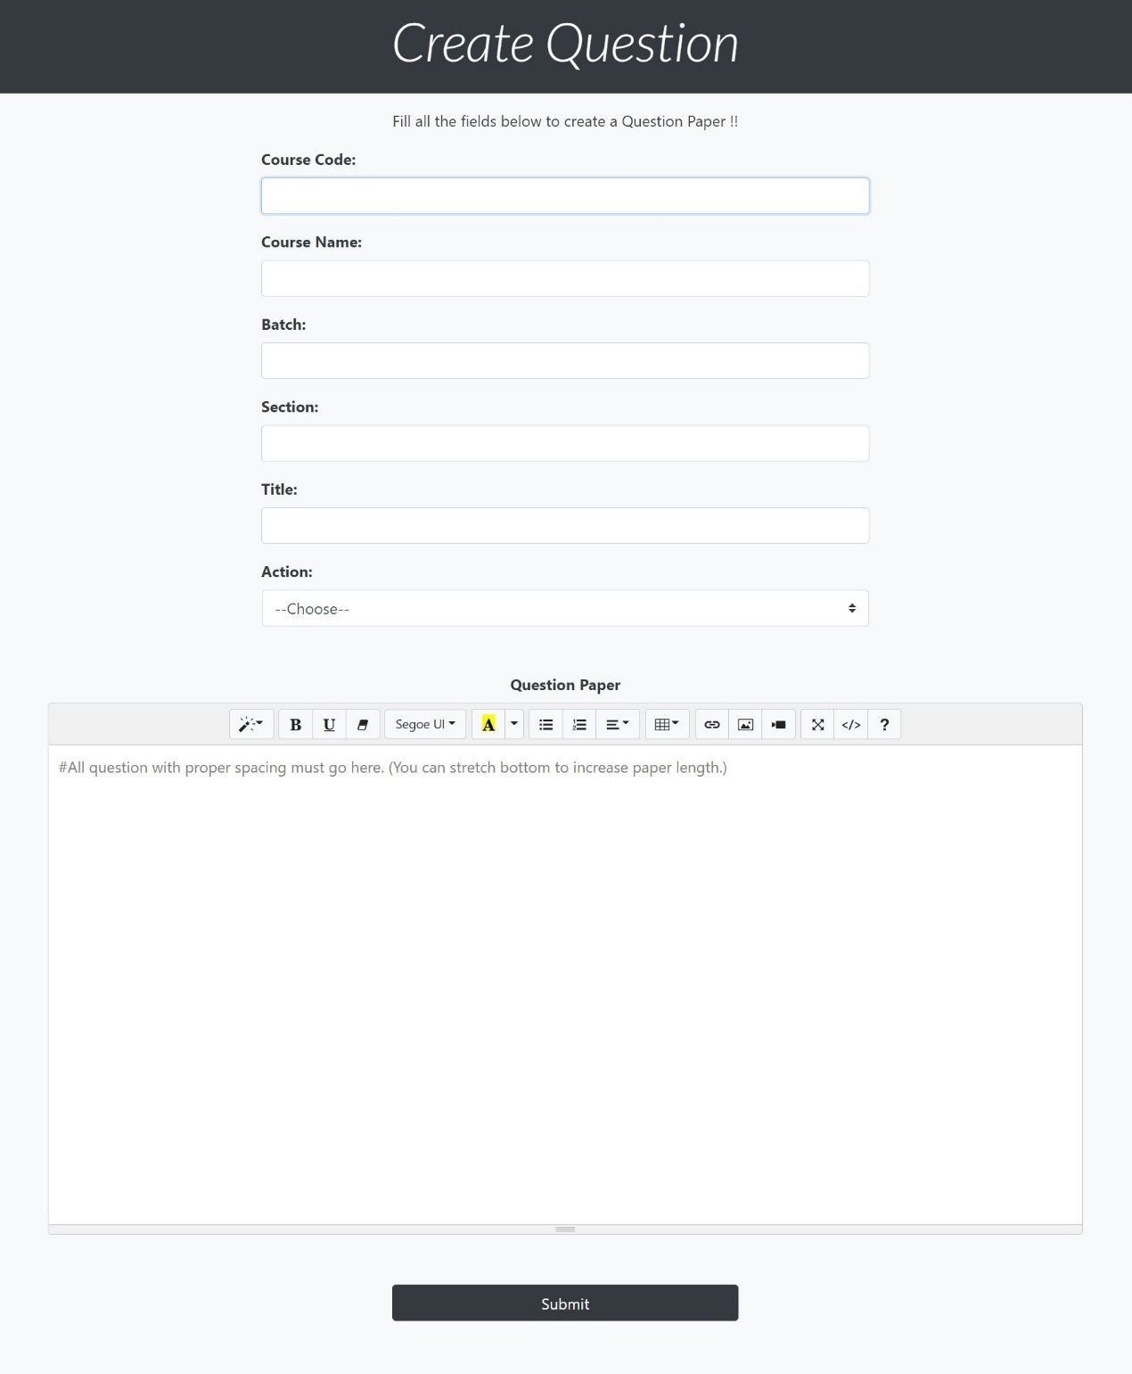

Figure 21: Create Question of Lu Exam Hive

Create Meeting (Teacher)

Lu Exam Hive integrates the 2 most popular meeting apps Google meet and Zoom into the website so teachers have all the necessities sorted in under one platform. Teachers on clicking any of 2 meeting buttons will be taken to the following sites to schedule a date for meeting and the link obtained will be copied by the teachers and pasted into our Meeting Link input field. On save teachers will get their meeting links organized in their dashboard.

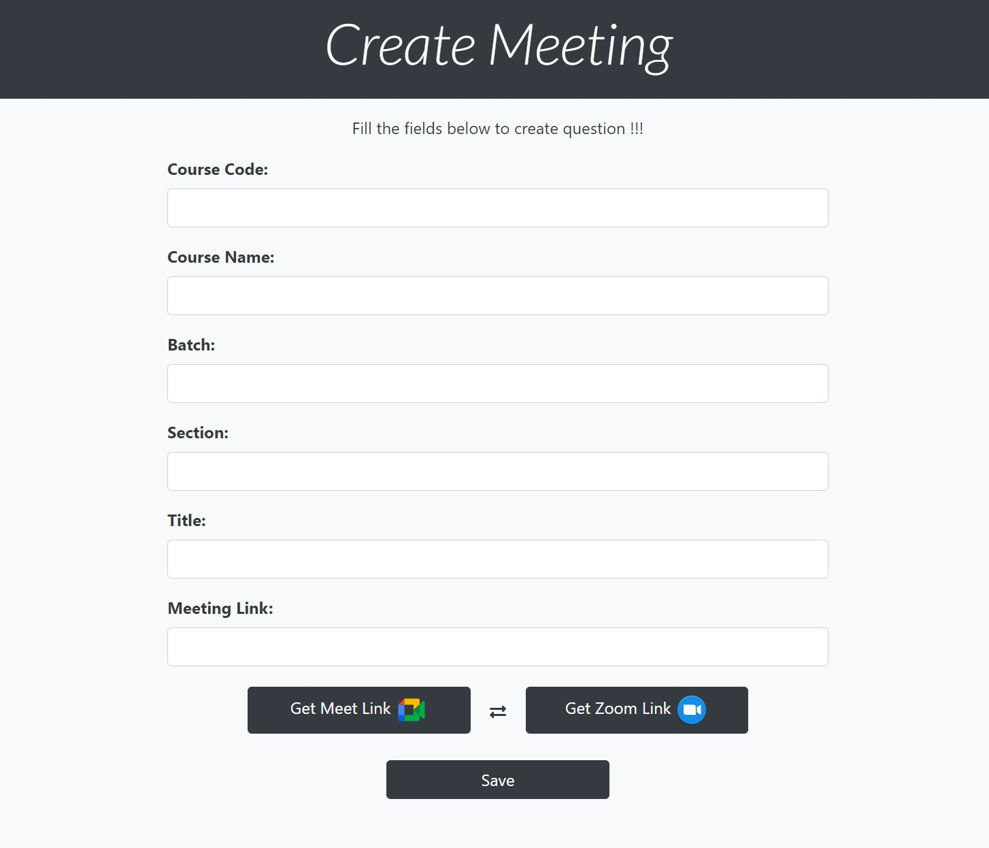

Figure 22: Create Meeting of Lu Exam Hive

Edit Question (Teacher)

Here teachers will be able to edit their questions after making them. If teachers didn’t choose any Action before or kept it to be Draft or Post and want to change it to something else can be performed here.

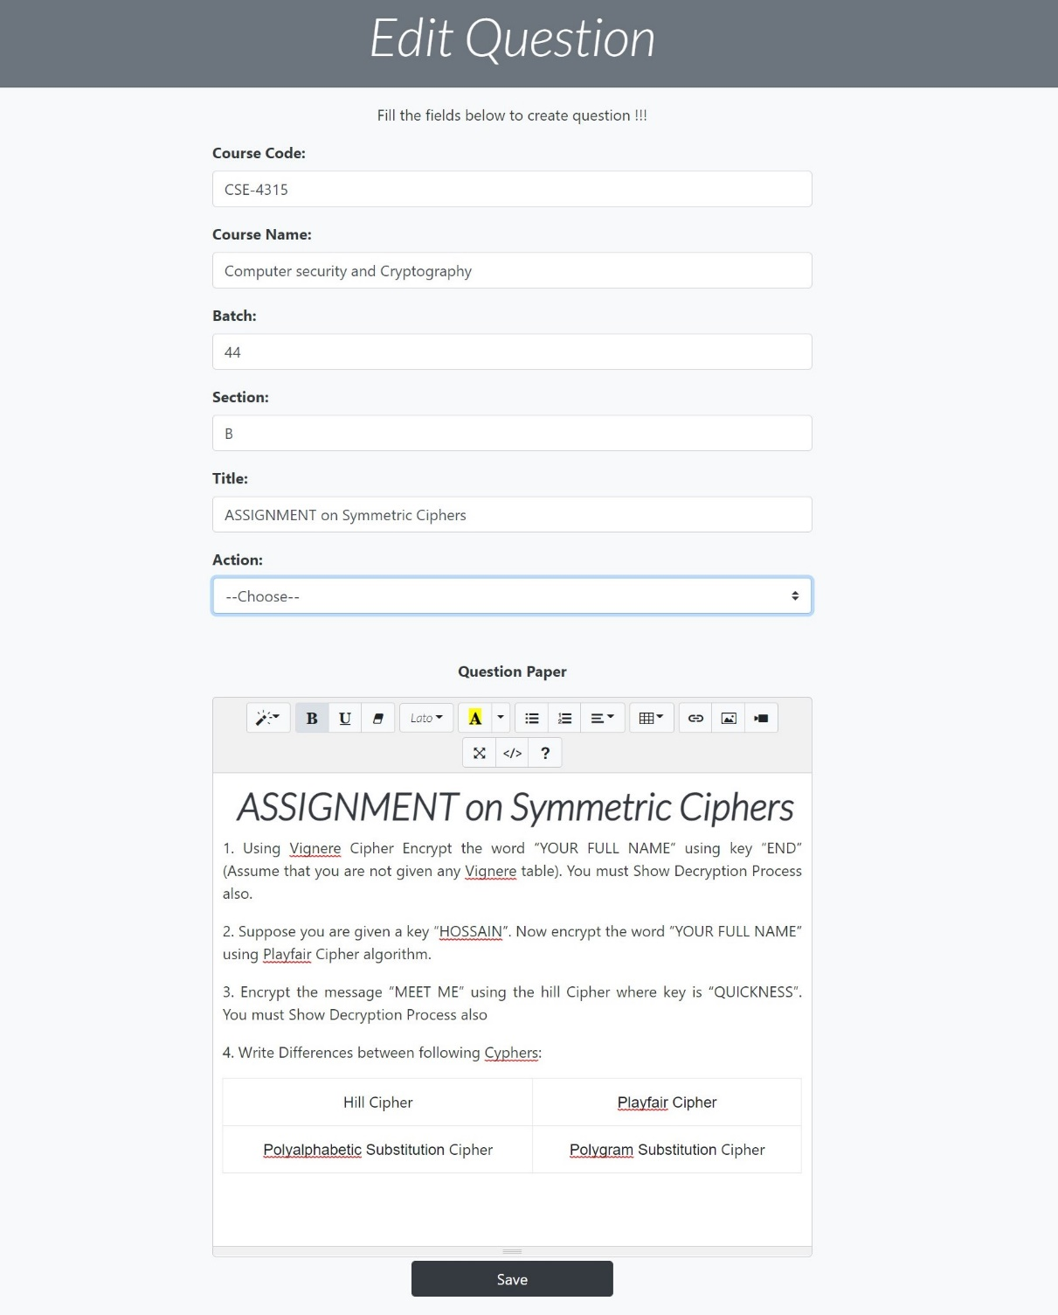

Figure 23: Edit Question of Lu Exam Hive

Question View (Teacher)

Teachers after making a question can view how it will appear on screen for students in this section and can also check the solutions submitted by students by clicking the submissions and result button.

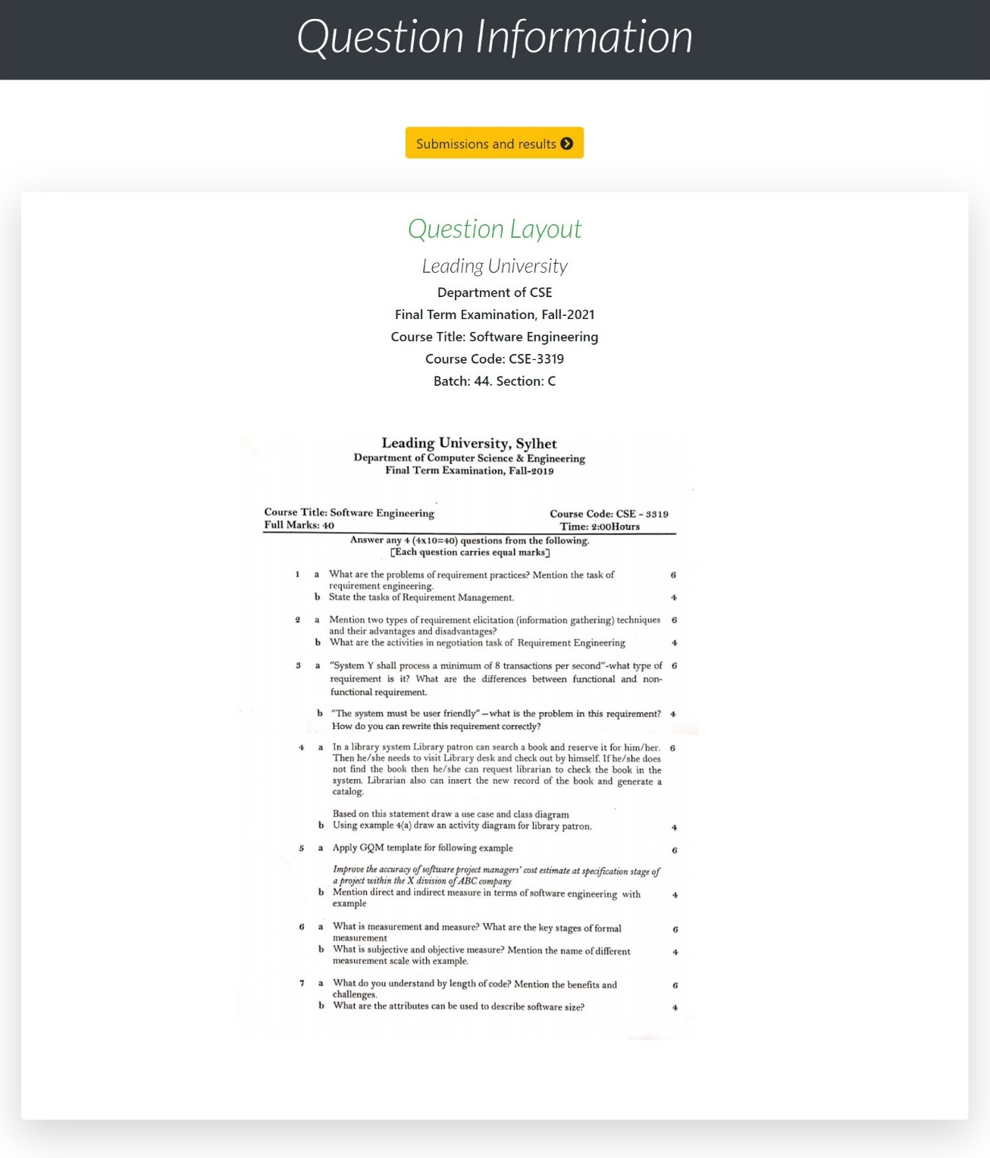

Figure 24: Question View of Lu Exam Hive

Posts (Teacher & Student)

This section displays the current posts of every teachers. It is visible to both teachers and students.

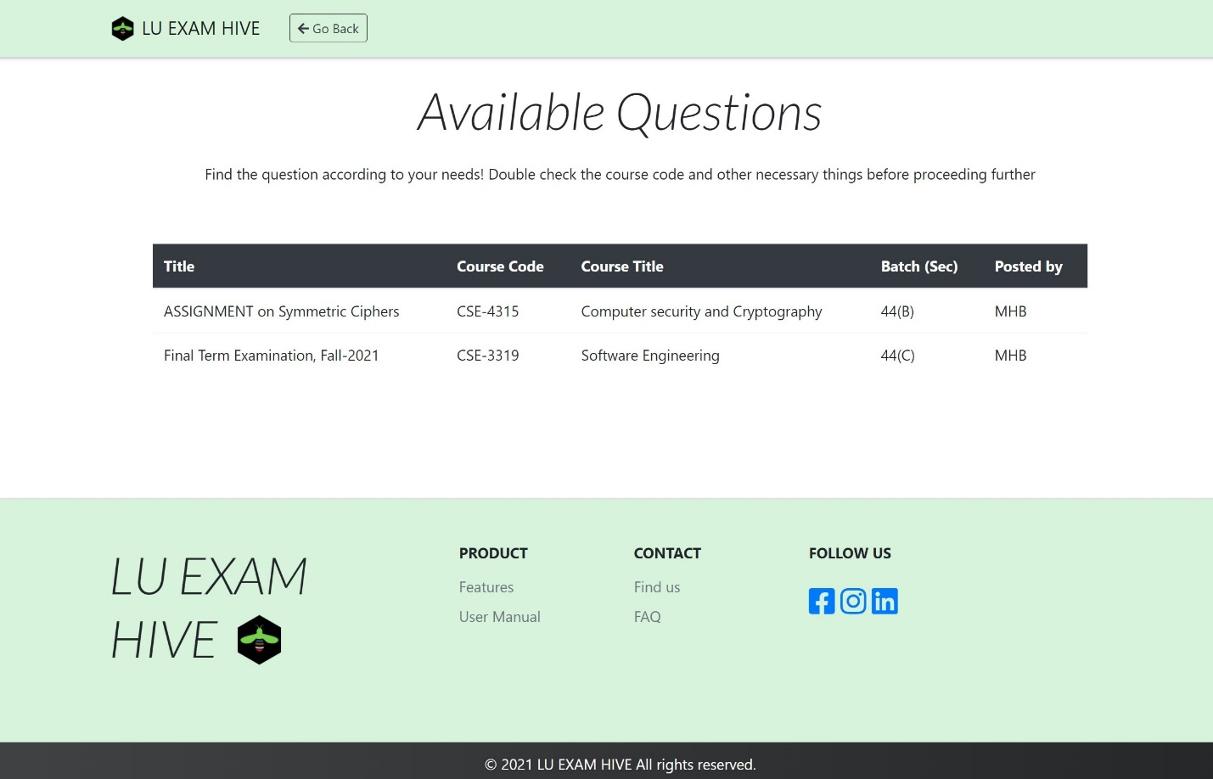

Figure 25: Posts of Lu Exam Hive

Submissions (Teacher)

All submitted solutions from students will appear here.

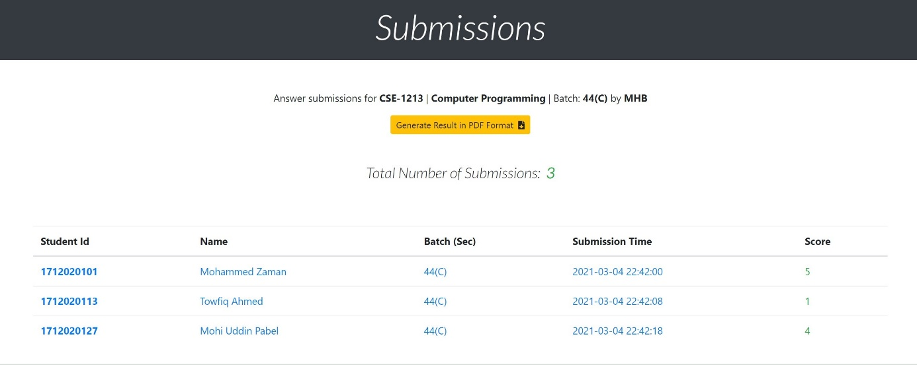

Figure 26: Submissions of Lu Exam Hive

PDF Generate (Teacher)

Teachers will be able to generate pdf of marks given to student submissions.

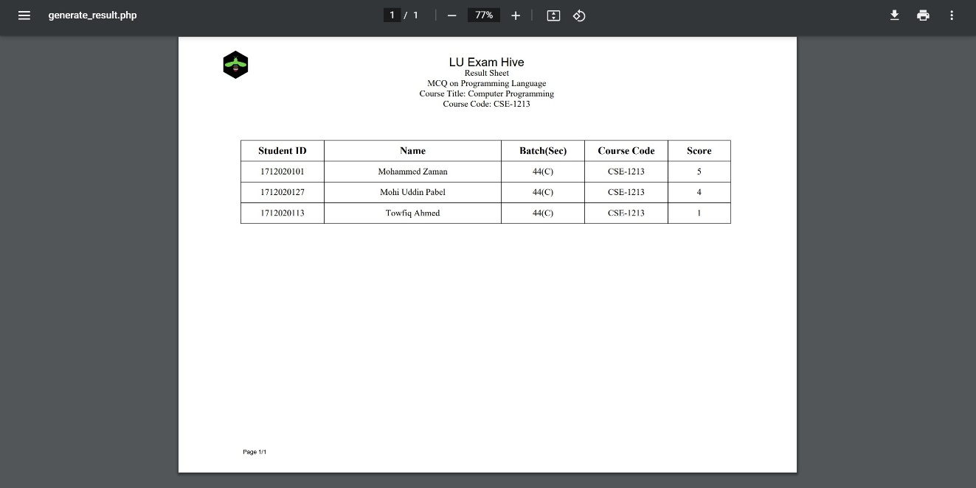

Figure 27: PDF Generate of Lu Exam Hive

Submission Details (Teacher)

Teachers will be able to check solutions of students keeping questions in front of them and provide them a score.

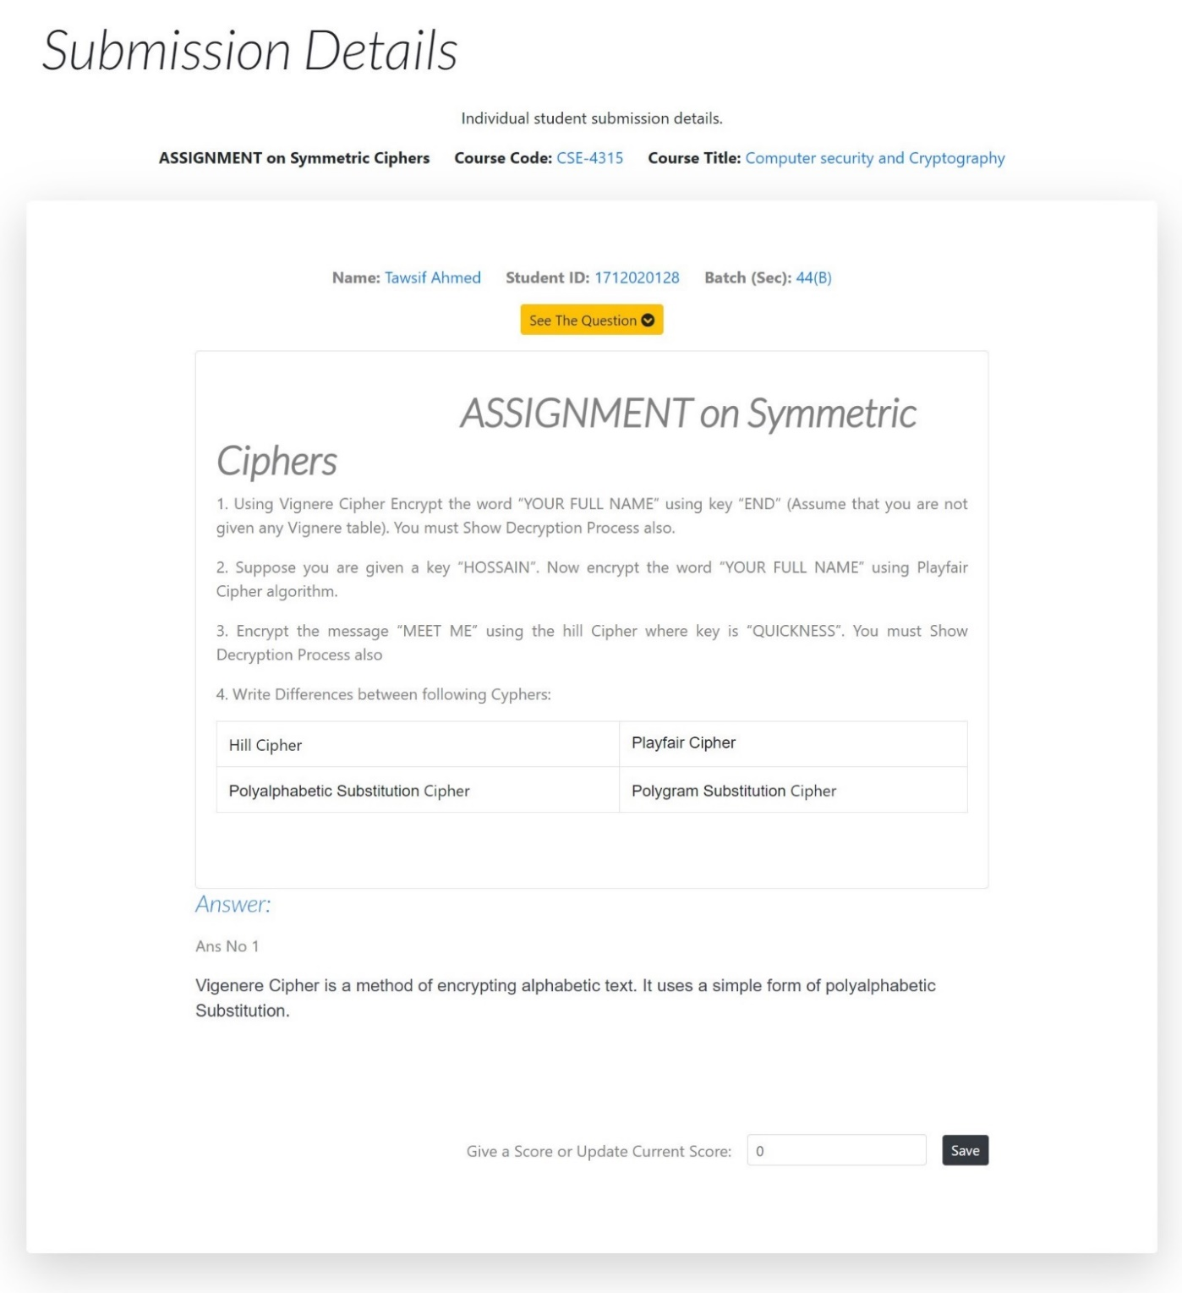

Figure 28: Submission Details of Lu Exam Hive

Dashboard (Student)

We simplified students dashboard keeping in mind not all students are used to complexity of online exam platforms. The table here generates only exams and meetings that is taking place within his/her section only and in case if a student wants to give exam with some other section can easily move to All Posted Questions where Exam details of all sections are present.

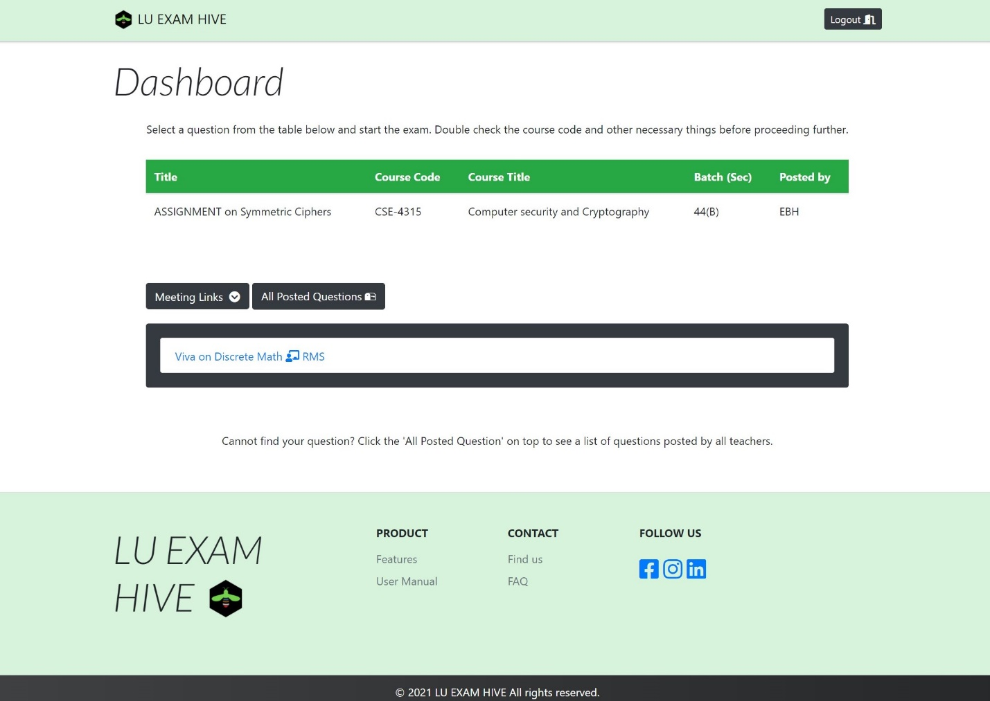

Figure 29: Student Dashboard of Lu Exam Hive

Answer Script (Student)

Students will answer in this section. They will have to attach their details before writing anything on the answer script.There is a digital clock integrated so they can keep tract of their time.

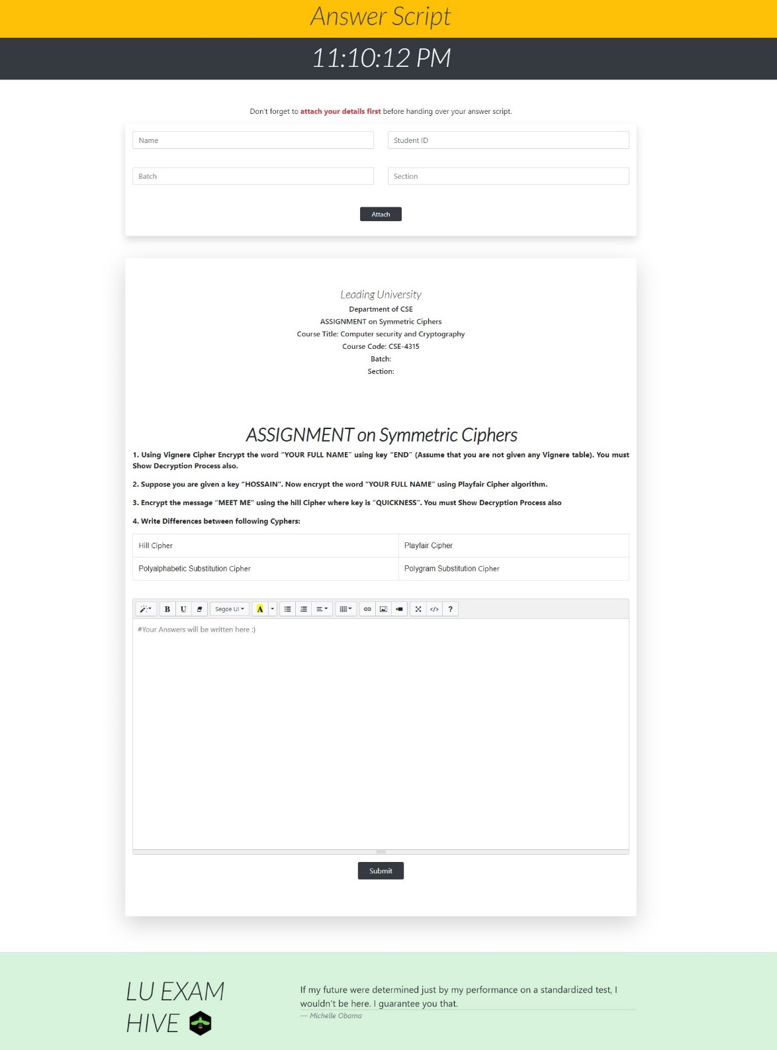

Figure 30: Answer Script of Lu Exam Hive

Dashboard (Admin)

Designed with simplicity in mind. Admin has access to all the details of user in the platform and contacting users.

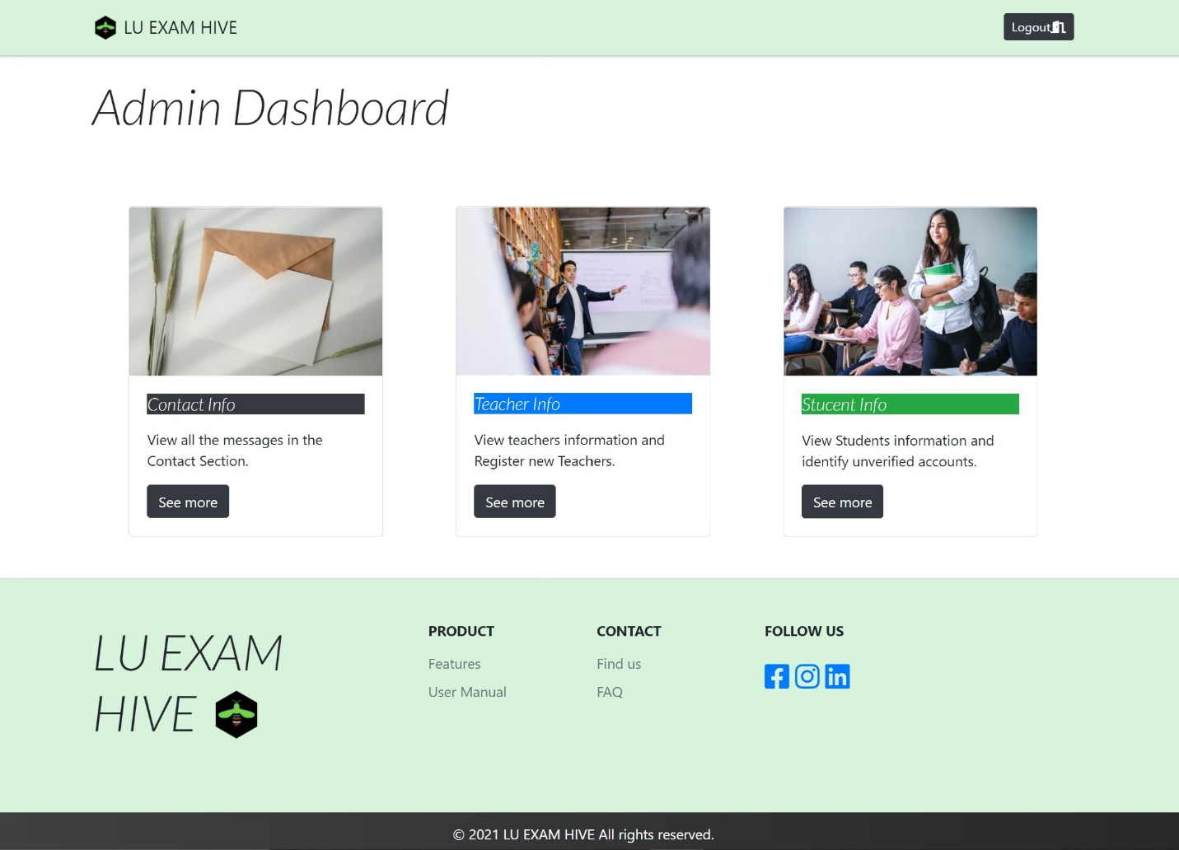

Figure 31: Admin Dashboard of Lu Exam Hive

Contact Info (Admin)

Here admins will have information of all the users contacting the website.

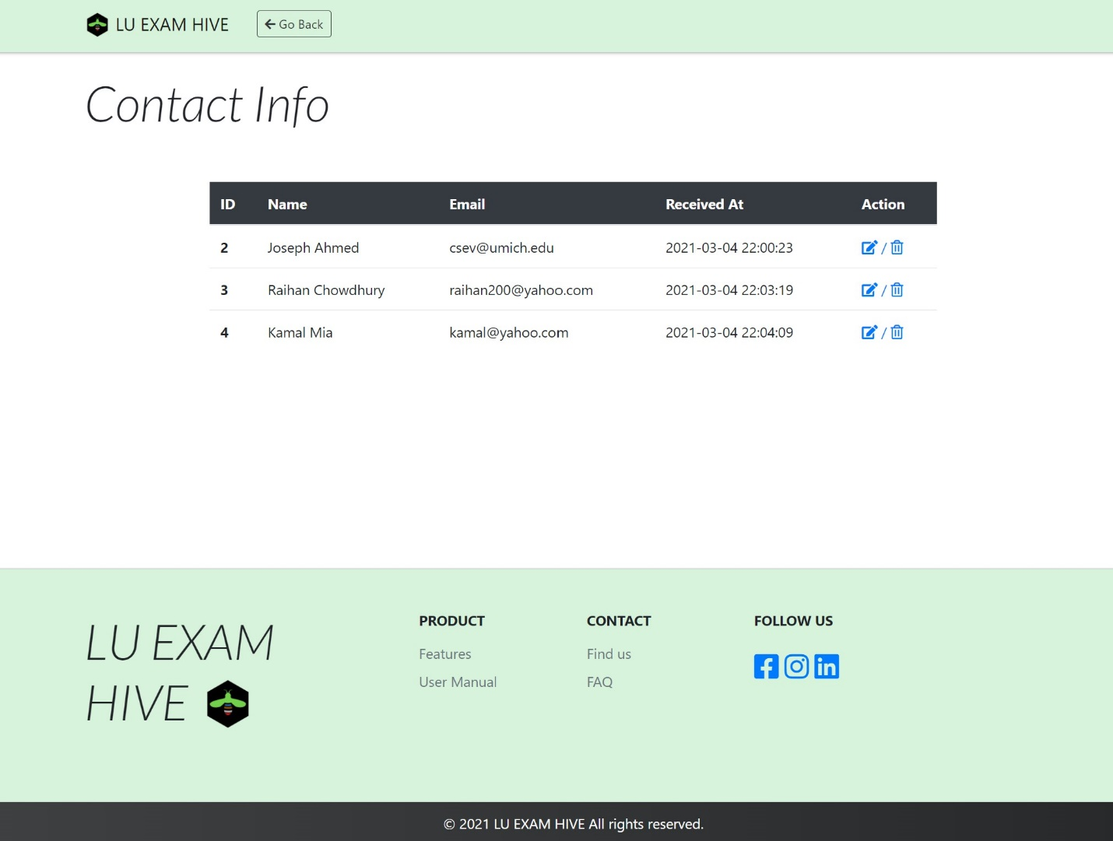

Figure 32: Contact Info of Lu Exam Hive

Contact Info Delete (Admin)

Admin can view the message of the contact and also delete it.

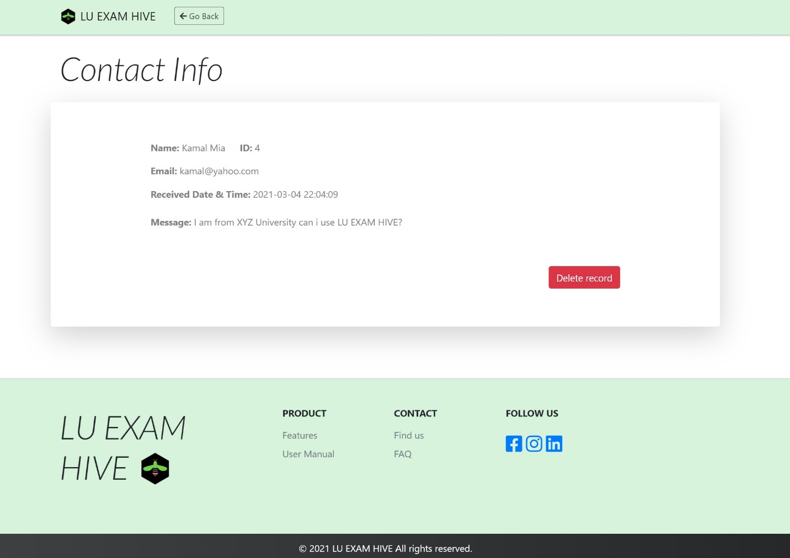

Figure 33: Contact Info Delete of Lu Exam Hive

Teacher Info (Admin)

Admin can view the teachers registered to the platform here and also go onto add new Teachers to the site.

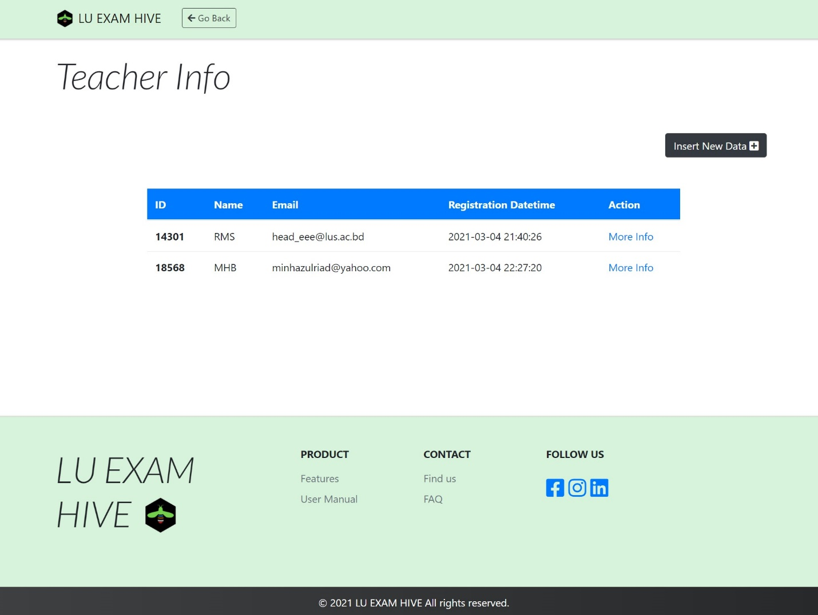

Figure 34: Teacher info of Lu Exam Hive

Insert Teacher Info (Admin)

Admin will be able to add new teacher by filling up the following.

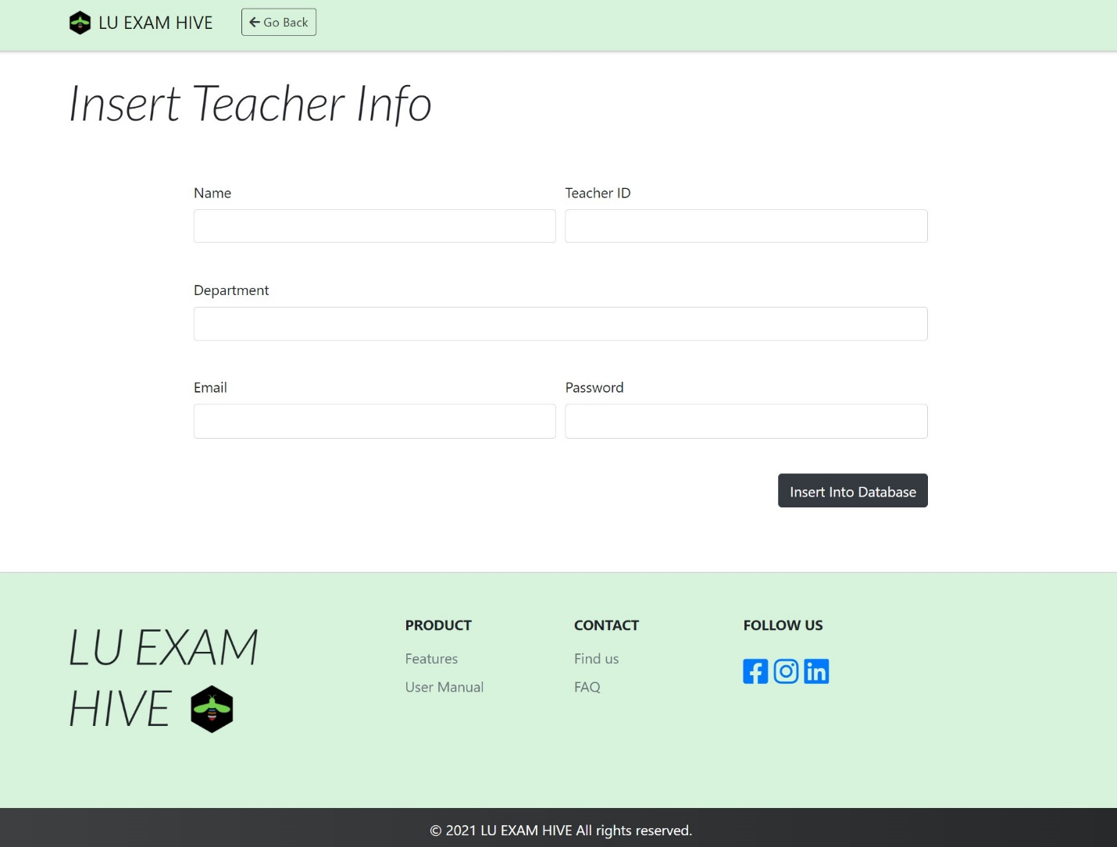

Figure 35: Insert Teacher Info of Lu Exam Hive

Student Info (Admin)

Admin will get a batch wise student details (includes number of student present in each batch) and also search for a specific student id and acquire all information easily.

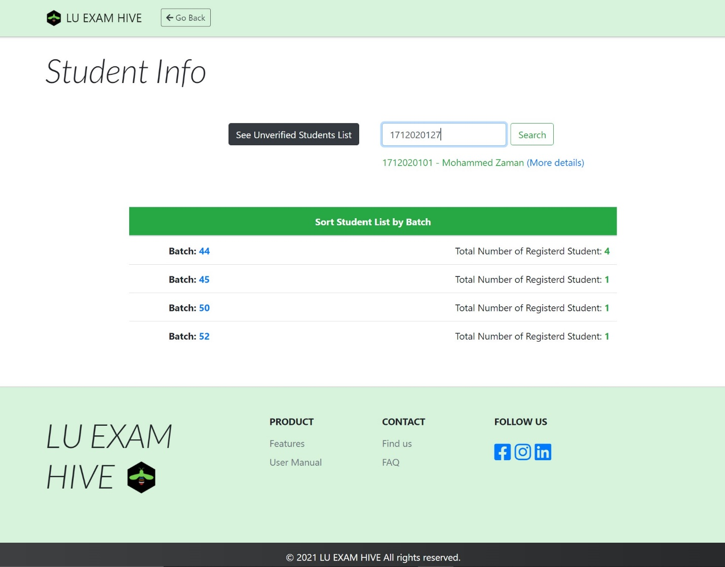

Figure 36: Student Info of Lu Exam Hive

Unverified Email List (Admin)

Admin can easily detect which users are still unverified and can take actions.

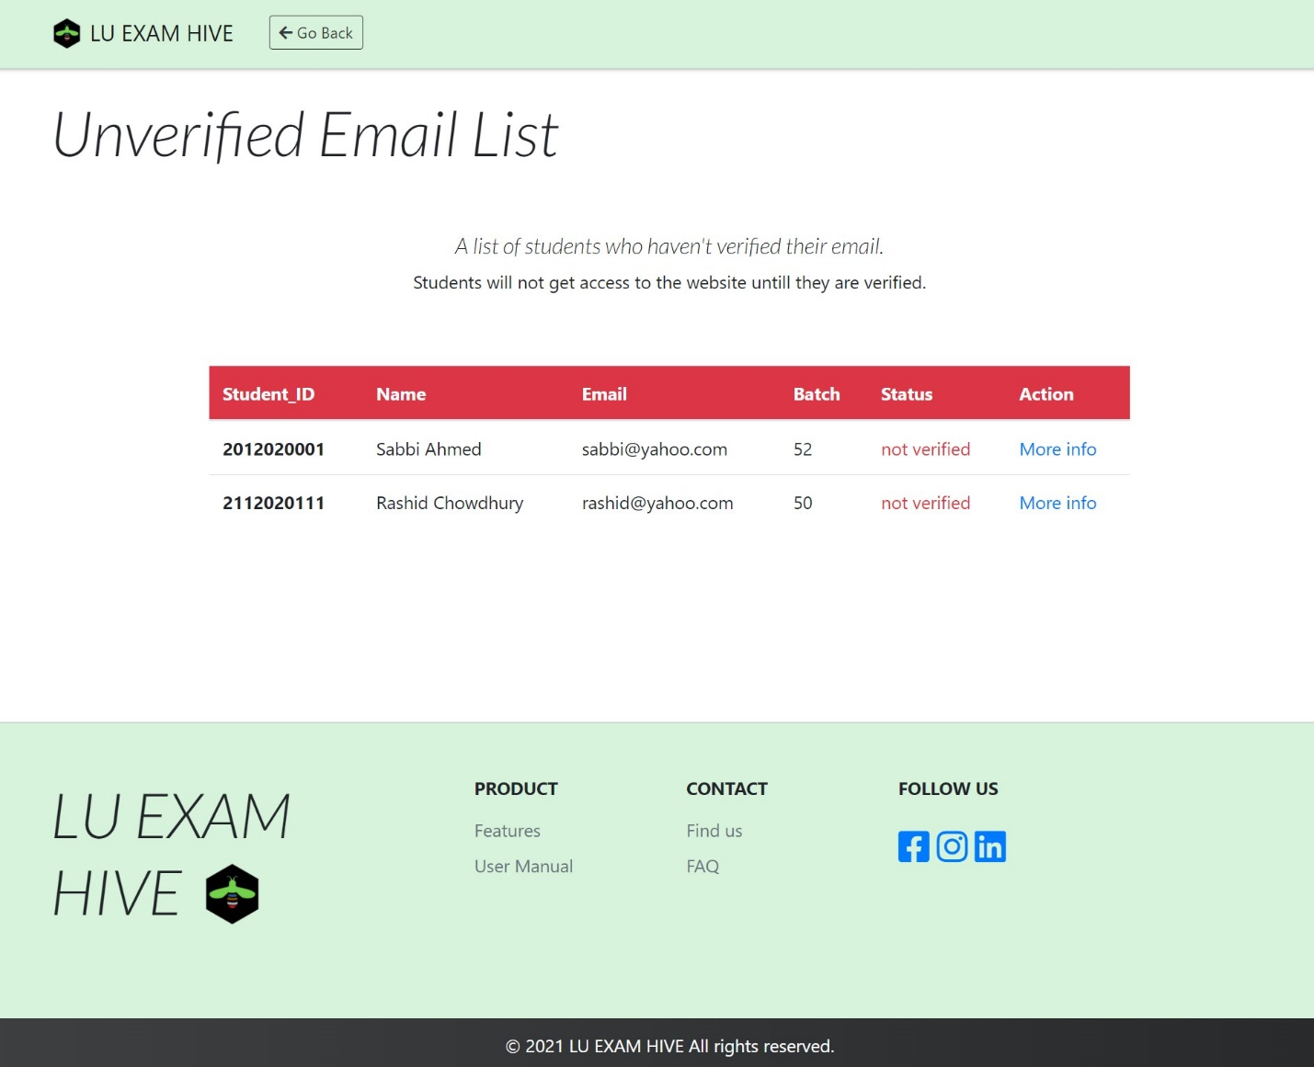

Figure 37: UI Flowcharts of Lu Exam Hive

Student Details (Admin)

Admin has the power to view details of a student’s Lu Exam Hive account and also delete their account.

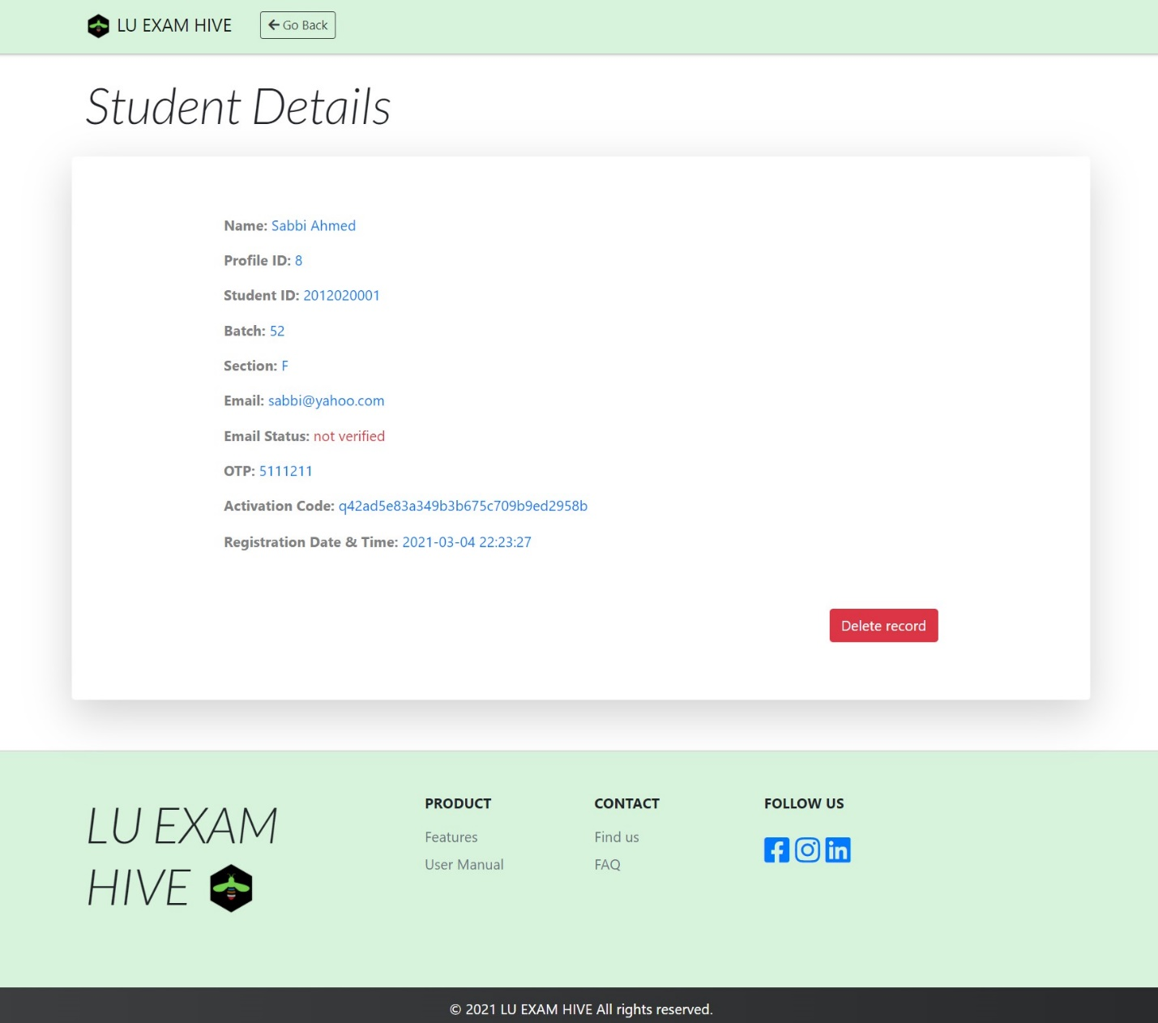

Figure 38: Student Details of Lu Exam Hive

Student Info by Batch (Admin)

Admins are given further ease to look into a particular batch and its sub sections.

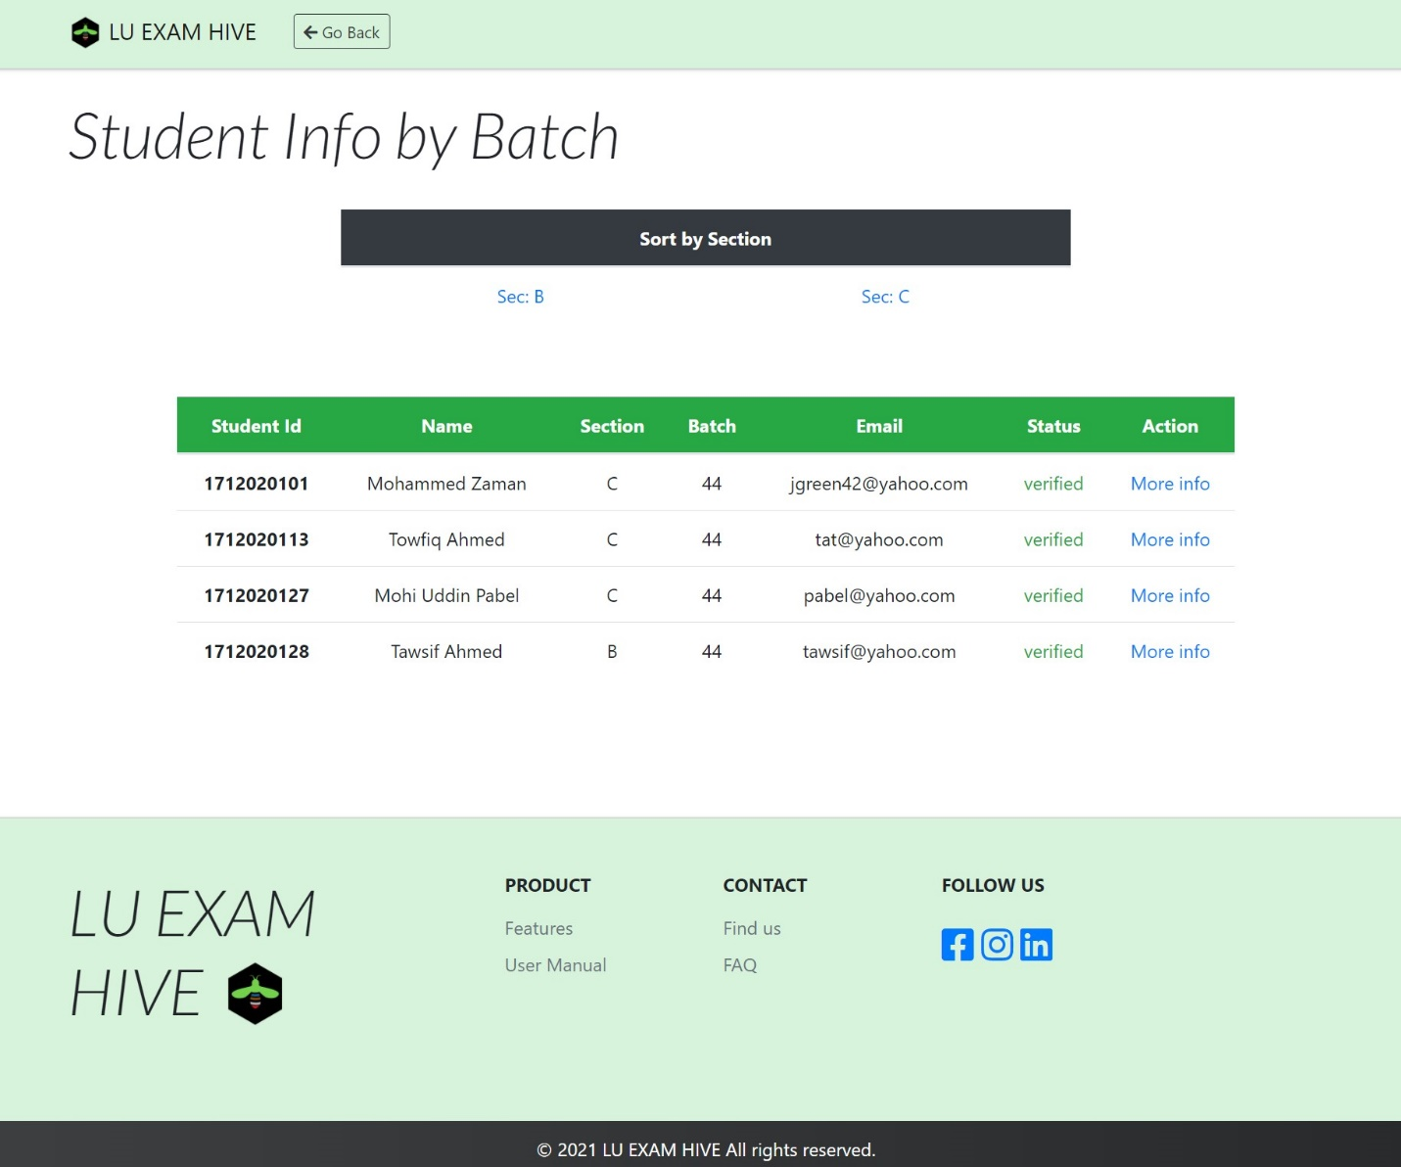

Figure 39: Student Info by Batch of Lu Exam Hive

Student Info by Section (Admin)

Admin can further view individual section and the number of students registered under them and more details on them.

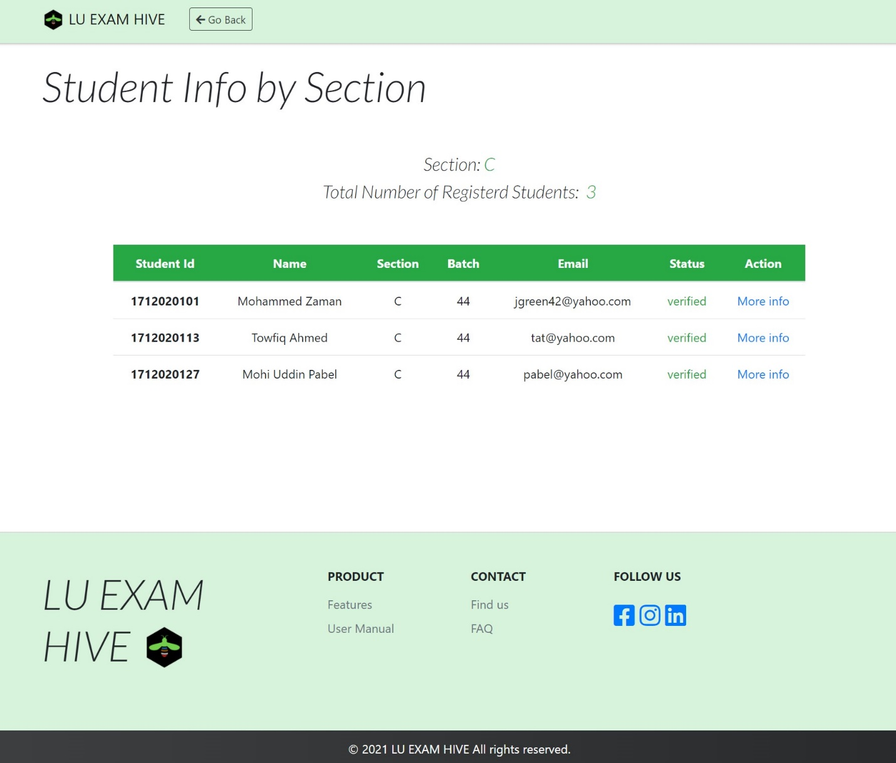

Figure 40: Student Info by Section of Lu Exam Hive

Lu Exam Hive (Logo)

The logo below is the Symbol of Lu Exam Hive Online Examination System. Lu Exam Hive has been created for Leading University Students Only. Leading University community has 4 distinct groups i.e. Teacher, Student, Administration and Staff. Here green resembles student, blue denote teacher, red points to the administration and the black is for the staff in transportation, and brown denotes the soil that holds all of us together in place, we all are connected to the same soil even though we have distinct roles in society. The colors are picked according to the ID card color used within our university premises. A student on his/her own can hardly succeed in life but together with proper guidance from professional teachers and well organized institution can reach the peak sooner then he/she expected. Such is the moto of the symbol below.



Figure 41: Lu Exam Hive Logo